Университет ИТМО

Факультет ФПИ и КТ

### Отчёт

### по лабораторной работе 1

**Системы Искуственного Интеллекта**

Студент:

Ляо Ихун

Преподаватель:  
Авдюшина Анна Евгеньевна

**Задача:**

Составить базу знаний на языке Пролог, которая будет содержать генеалогическое дерево семьи с указанием родственных отношений.

**Картика:**

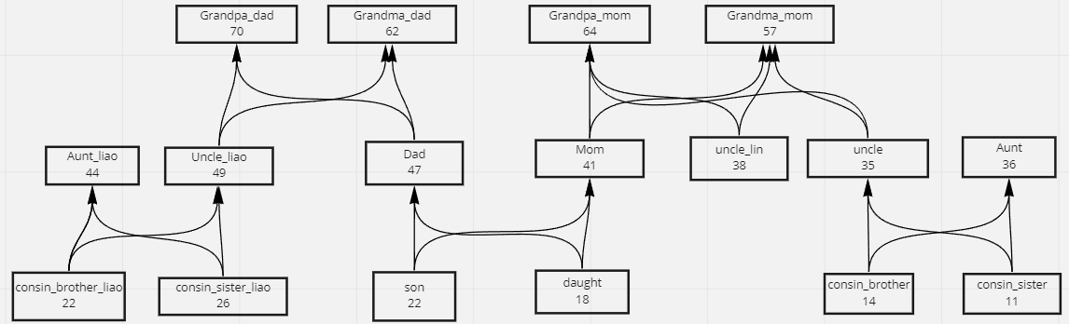

**Примеры:  
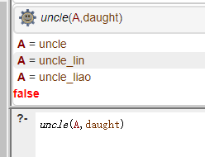**

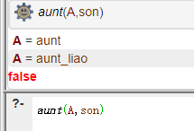

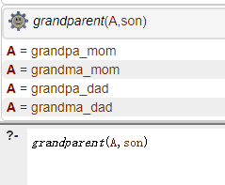

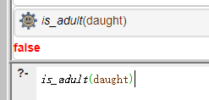

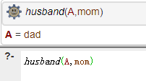

**Код:**

%facts%

age(son,22).

age(daught,18).

age(dad,47).

age(mom,41).

age(grandpa_mom,64).

age(grandma_mom,57).

age(uncle_liao,49).

age(uncle,35).

age(uncle_lin,38).

age(grandpa_dad,70).

age(grandma_dad,62).

age(cosin_sister_liao,26).

age(cosin_brother_liao,22).

age(cosin_brother,17).

age(cosin_sister,13).

age(aunt_liao,44).

age(aunt,36).

man(son).

man(dad).

man(uncle).

man(grandpa_mom).

man(cosin_brother).

man(grandpa_dad).

man(uncle_liao).

man(cosin_brother_liao).

man(uncle_lin).

woman(cosin_sister_liao).

woman(aunt_liao).

woman(grandma_dad).

woman(daught).

woman(mom).

woman(aunt).

woman(cosin_sister).

woman(grandma_mom).

parent(uncle_liao,cosin_brother_liao).

parent(uncle_liao,cosin_sister_liao).

parent(aunt_liao,cosin_brother_liao).

parent(aunt_liao,cosin_sister_liao).

parent(mom,son).

parent(mom,daught).

parent(dad,son).

parent(dad,daught).

parent(grandpa_mom,mom).

parent(grandma_mom,mom).

parent(grandpa_mom,uncle).

parent(grandma_mom,uncle).

parent(grandma_mom,uncle_lin).

parent(grandpa_mom,uncle_lin).

parent(uncle,cosin_sister).

parent(uncle,cosin_brother).

parent(aunt,cosin_brother).

parent(aunt,cosin_sister).

parent(grandpa_dad,dad).

parent(grandma_dad,dad).

parent(grandma_dad,uncle_liao).

parent(grandpa_dad,uncle_liao).

couple(mom,dad).

couple(grandpa_dad,grandma_dad).

couple(grandpa_mom, grandma_mom).

couple(aunt,uncle).

couple(aunt_liao,uncle_liao).

couple(dad,mom).

couple(grandma_dad,grandpa_dad).

couple(grandma_mom, grandpa_mom).

couple(uncle,aunt).

couple(uncle_liao,aunt_liao).

%rules%

%couple(A,B):- couple(B,A),!.%

son(A,B):-parent(B,A), man(A).

daught(A,B):-parent(B,A),woman(A).

dad(A,B):-parent(A,B),man(A).

mom(A,B):-parent(A,B),woman(A).

brother(A,B):- dad(F1,A), dad(F2,B),F1=F2, mom(M1,A), mom(M2,A), M1=M2, man(A),\+A=B.

sister(A,B):- dad(F1,A), dad(F2,B),F1=F2, mom(M1,A), mom(M2,B), M1=M2, woman(A),\+A=B.

husband(A,B):-couple(A,B),man(A),woman(B).

wife(A,B):-couple(A,B),woman(A),man(B).

%two possibility for uncle

possibility_u1(A,B):-man(A),mom(M,B),sister(M,A).

possibility_u2(A,B):-man(A),dad(D,B),brother(D,A).

uncle(A,B):-possibility_u1(A,B);possibility_u2(A,B).

aunt(A,B):- uncle(C,B),wife(A,C).

grandparent(A,B):-parent(C,B), parent(A,C).

is_adult(A):- age(A,Age),Age>18.